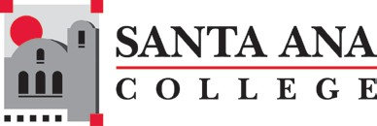

SANTA ANA COLLEGE
Enrollment Management Committee
Tuesday, May 20, 2025, 3:30pm – 5:00pm
Zoom
Agenda

- Welcome
- Action: Approval of Minutes: April Meeting
- Information: Fraudulent Student Enrollment Update and Census Verification (Mark DeAsis)
- Information: Standard Accounting Process Update (Claire Coyne)
- Information: Enrollment Academy Update (Matt Morin)
- Discussion: Enrollment Management Retreat
- Action: Approval of 2025-2026 Meeting Schedule (3rd Tuesday of the Month)

EMC Meetings will be held on the third Tuesday from 3:30-5:00pm of each month unless otherwise noted
Fall 2025: September 16, 2025, | October 21, 2025, | November 18, 2025
Spring 2026: February 17, 2026, | March 17, 2026, | April 21, 2026, | May 19, 2026

